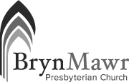
BRYN MAWR PRESBYTERIAN CHURCH ~ PEACEMAKING COMMITTEE
FUNDING REQUEST

Name of Organization: 501(c)(3)?  Yes  No
Contact Person: Email:
Address: Website:
Mailing Address for donation, if different:
Organization’s Mission:

Organization’s annual budget: $
Goals of the  existing or  new program for which you are requesting support:

If this is a new program, describe plans to sustain the program beyond the start-up period:

Describe the impact a donation of $500 - $700 would have on the program:

Explain how this project furthers the work of peacemaking:

Is there any way for our congregation members to get involved in this program?

Return this form to Phoebe Sheftel at pasheftel@gmail.com.

